some projects in Jira have not been touched for a while. could you please do the following to keep them up to date.

1. **Log into Jira 🡪 issues (menu bar) 🡪 search for issues**
2. **Copy following query into search box, replace ‘e.wang’ with your own account name .**

project in ("APL Bug Fixes","APL Development","Asset Management","Broker API","Business Intelligence","CT Application Process Defect","EziDebit Integration","Full Online Application Form","IT Project List","Member Area","Stage Manager - Agile","Unified Communications") AND status was not in (CLOSED, Resolved, "Ready for Rollout", Done,Disposed) AND assignee = e.wang

1. **Click search icon, you will see unresolved tasks that assigned to you (help desk and laps project are not included).**

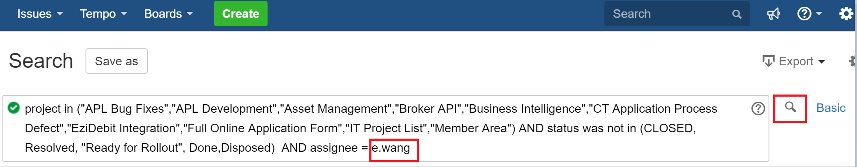

1. **Go through them and update if need to**